WORKING WITH PARAMTERIZED JOBS AND TRIGGERS

* Under Jenkins Dashboard , Click on New Item and create a new freestyle

project and check the box which says “This project is Parameterized”

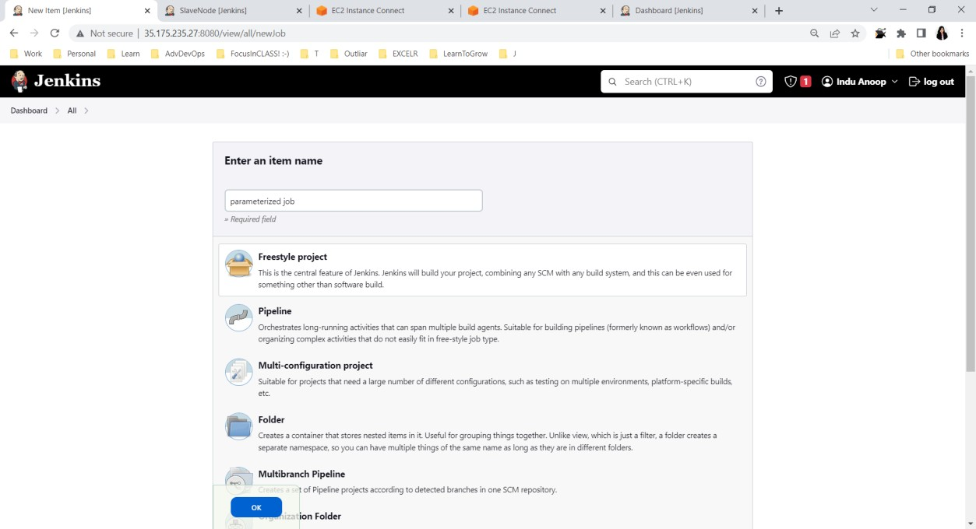

* Choose Choice Parameter and provide the details of operating system as given below and Click on Apply

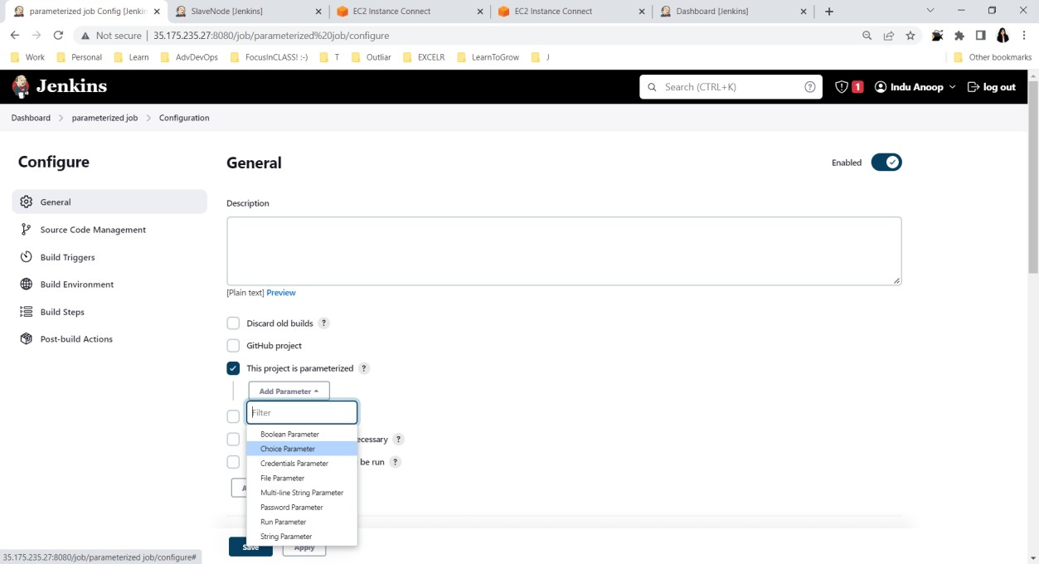

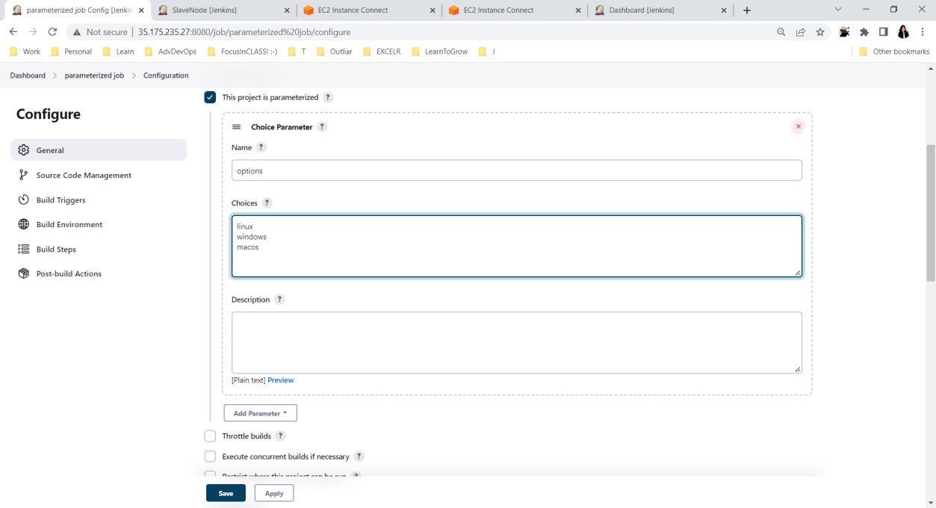

* Now under Build Environment, choose Add Build Step and click on Execute shell option

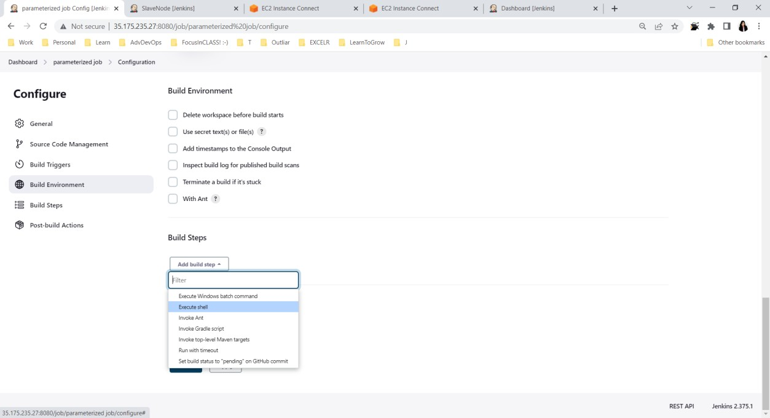

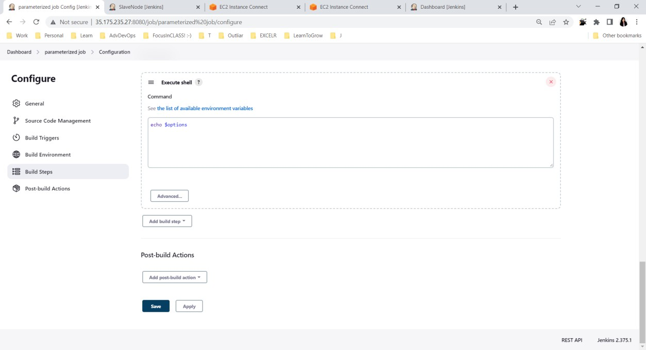

* Now Under Jenkins Dashboard let us build the project by clicking on

“Build with Parameters” and observe the Console Output.

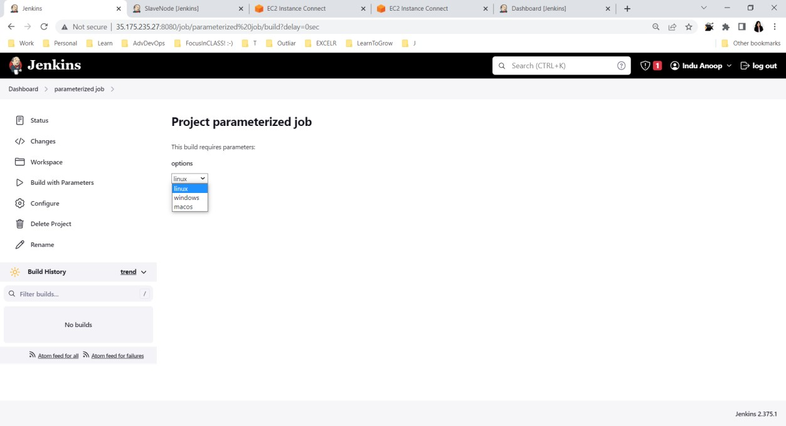

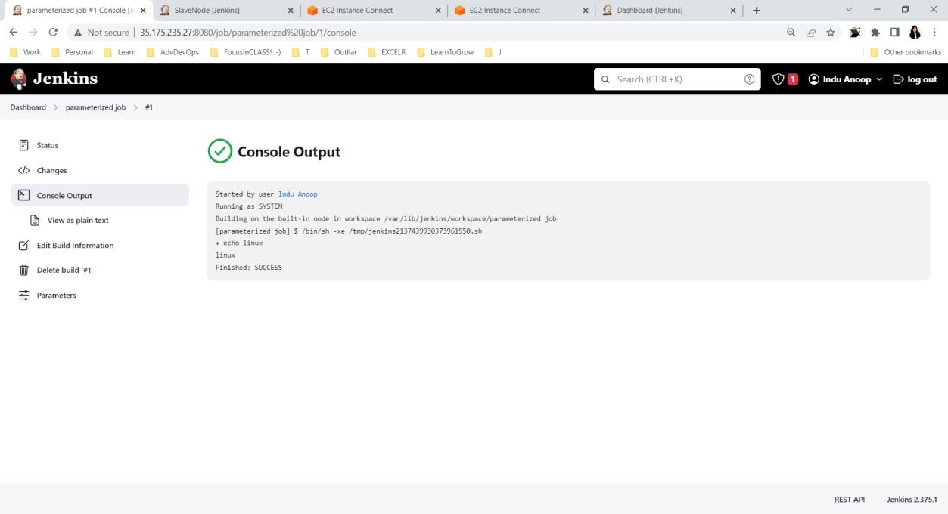

* Let us create a new job called as Parameterized trigger which will be triggered once Parameterized build is completed.

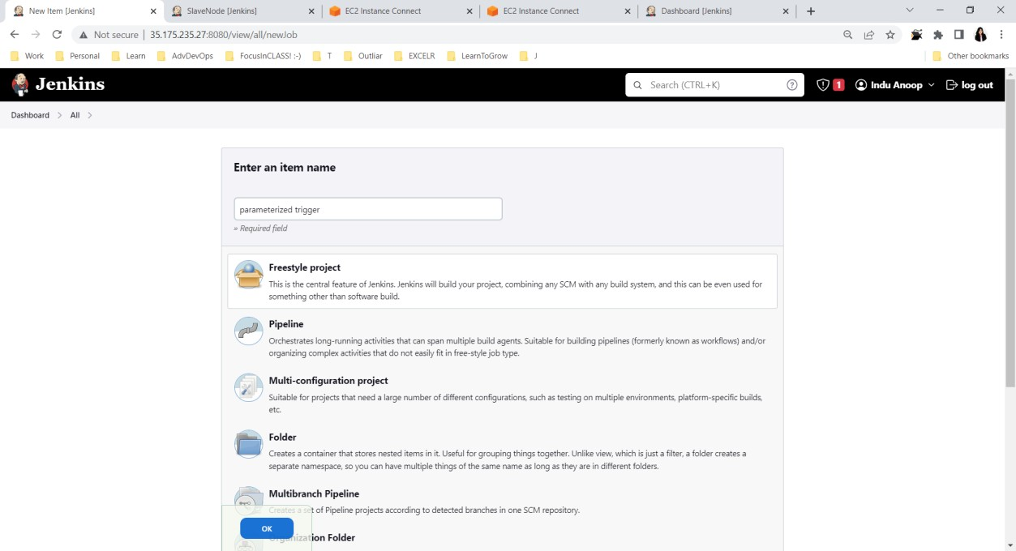

* Under Build Triggers choose Parameterized job under Projects to watch

.Apply and save.

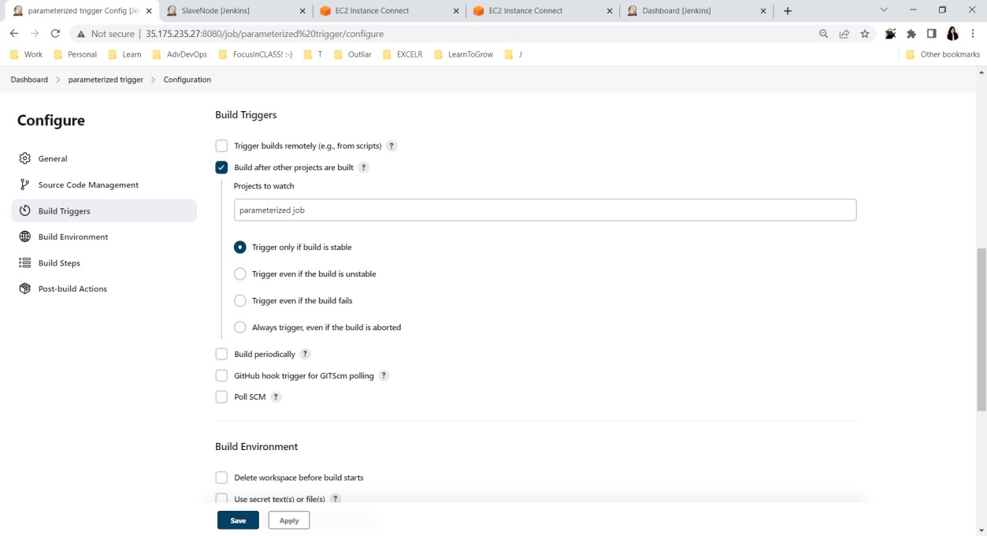

* Now click on **Build with Parameters** and observe the outputs

